Training Guide for Sales and Customer Support

**\*Key features of the product**

-features : related to motivation

-reward system : external motivation tool to help patient to form good habit

-user can collect points by accomplishing mission. reward can be selected with points

-health test : deeper understand of own body

-help understand body in number and graphic

-internal motivation by facing seriousness of body condition

-24/7 Q&A : sense of bond and relation formed

-user can ask any questions

**\*Benefits to users and consumers**

-benefits : main value of this app is motivation

-companion

-with app, user can have sense of bond (it is important, because patient need emotional help)

-remote support

-Q&A is available

-individualized process

-personalized activity given

-respect user’s goal

**\*How to use the product**

How : with mobile application

-below are steps for using app

1.test the body condition

2.base on the body condition, app gives appropriate mission to become active

3.when patients accompolish the mission, they get points

4.some patients can get stars when they constantly finishing mission well

5.with points and star, patient can get discount

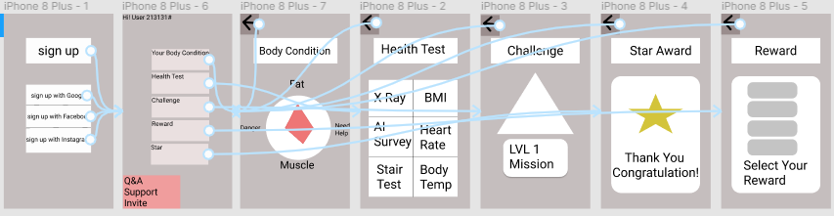

[**https://www.figma.com/file/XNOCu64OWQEIiyqgZRBjBO/Udacity_project2?node-id=0%3A1**](https://www.figma.com/file/XNOCu64OWQEIiyqgZRBjBO/Udacity_project2?node-id=0%3A1)

**link for prototype of the app**

**\*Where users can find the product**

-three channels : app store, sns, web banner

-app store : it is where app can download

-app traffic is important to be on the top list in the store

-SNS : people communication place

-buzz effect, center of online place

-Web banner : ads on the sidebar of the web

-there is personalized AI ad to match target user